**STATIC ANALYSIS**

**Front-End(UI)**

**Tools used:**

1. JsHint (For Javascript objects and files)
2. HTML Tidy (For HTML5 source and DOM)

Automated Code Analysis

**JSHint**

**Rules Used:**

**Report**

Cyclomatic complexity

Unused variables

Undefined variables

**Warn**

About == null

About debugging code

About unsafe for..in

About arguments.caller and .callee

About assignments if/for/...

About functions inside loops

About eval

About unsafe line breaks

About potential typos in logical operators

When new is used for side-effects

**Legend:**

Fixed

Not a problem

**Results for service.js**

***51 warnings:***

2 'let' is available in ES6 (use 'esversion: 6') or Mozilla JS extensions (use moz).

6 'let' is available in ES6 (use 'esversion: 6') or Mozilla JS extensions (use moz).

6 Missing semicolon.

7 ['status'] is better written in dot notation.

8 Missing semicolon.

10 ['message'] is better written in dot notation.

11 Missing semicolon.

15 'let' is available in ES6 (use 'esversion: 6') or Mozilla JS extensions (use moz).

19 'let' is available in ES6 (use 'esversion: 6') or Mozilla JS extensions (use moz).

19 Missing semicolon.

20 ['status'] is better written in dot notation.

21 Missing semicolon.

23 ['message'] is better written in dot notation.

24 Missing semicolon.

29 'let' is available in ES6 (use 'esversion: 6') or Mozilla JS extensions (use moz).

33 'let' is available in ES6 (use 'esversion: 6') or Mozilla JS extensions (use moz).

33 Missing semicolon.

34 ['status'] is better written in dot notation.

35 Missing semicolon.

37 ['message'] is better written in dot notation.

38 Missing semicolon.

42 'let' is available in ES6 (use 'esversion: 6') or Mozilla JS extensions (use moz).

46 'let' is available in ES6 (use 'esversion: 6') or Mozilla JS extensions (use moz).

46 Missing semicolon.

47 ['status'] is better written in dot notation.

49 Missing semicolon.

51 ['message'] is better written in dot notation.

52 Missing semicolon.

57 'let' is available in ES6 (use 'esversion: 6') or Mozilla JS extensions (use moz).

61 'let' is available in ES6 (use 'esversion: 6') or Mozilla JS extensions (use moz).

61 Missing semicolon.

62 ['status'] is better written in dot notation.

63 Missing semicolon.

65 ['message'] is better written in dot notation.

66 Missing semicolon.

71 'let' is available in ES6 (use 'esversion: 6') or Mozilla JS extensions (use moz).

75 'let' is available in ES6 (use 'esversion: 6') or Mozilla JS extensions (use moz).

75 Missing semicolon.

76 ['status'] is better written in dot notation.

77 Missing semicolon.

79 ['message'] is better written in dot notation.

80 Missing semicolon.

90 Missing semicolon.

91 ['status'] is better written in dot notation.

92 Missing semicolon.

94 ['message'] is better written in dot notation.

95 Missing semicolon.

100 'let' is available in ES6 (use 'esversion: 6') or Mozilla JS extensions (use moz).

104 'let' is available in ES6 (use 'esversion: 6') or Mozilla JS extensions (use moz).

104 Missing semicolon.

104 Missing semicolon.

105 ['status'] is better written in dot notation.

108 ['message'] is better written in dot notation.

121 ['status'] is better written in dot notation.

124 ['message'] is better written in dot notation.

***Two undefined variables:***

86 request

87 request

88 request

89 request

90 request

114 request

115 request

116 request

118 request

120 request

90 response

91 response

94 response

120 response

121 response

124 response

***Nine unused variables*** *(not a problem since called elsewhere)*

1 registerUser

14 loginService

28 logoutService

41 verifyEmail

56 requestEmail

70 addTransaction

85 verifyPayment

99 transactionService

113 verifyPassword

**Fixed code:**

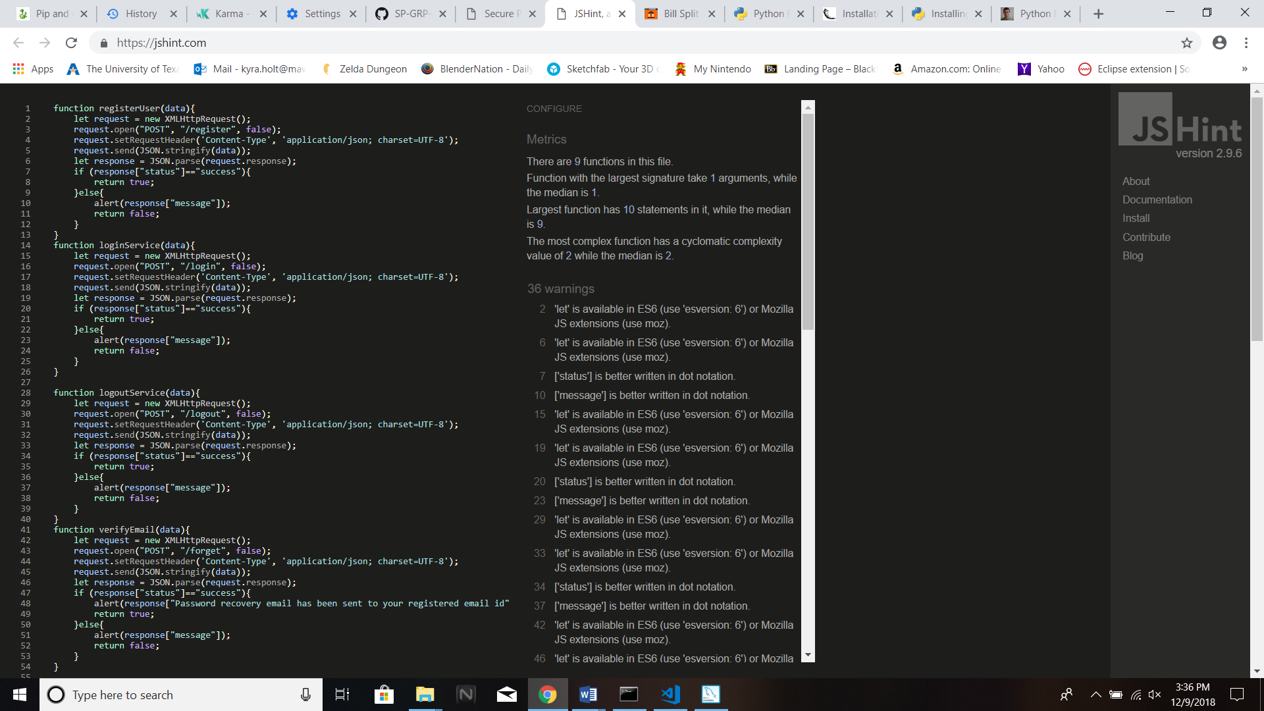

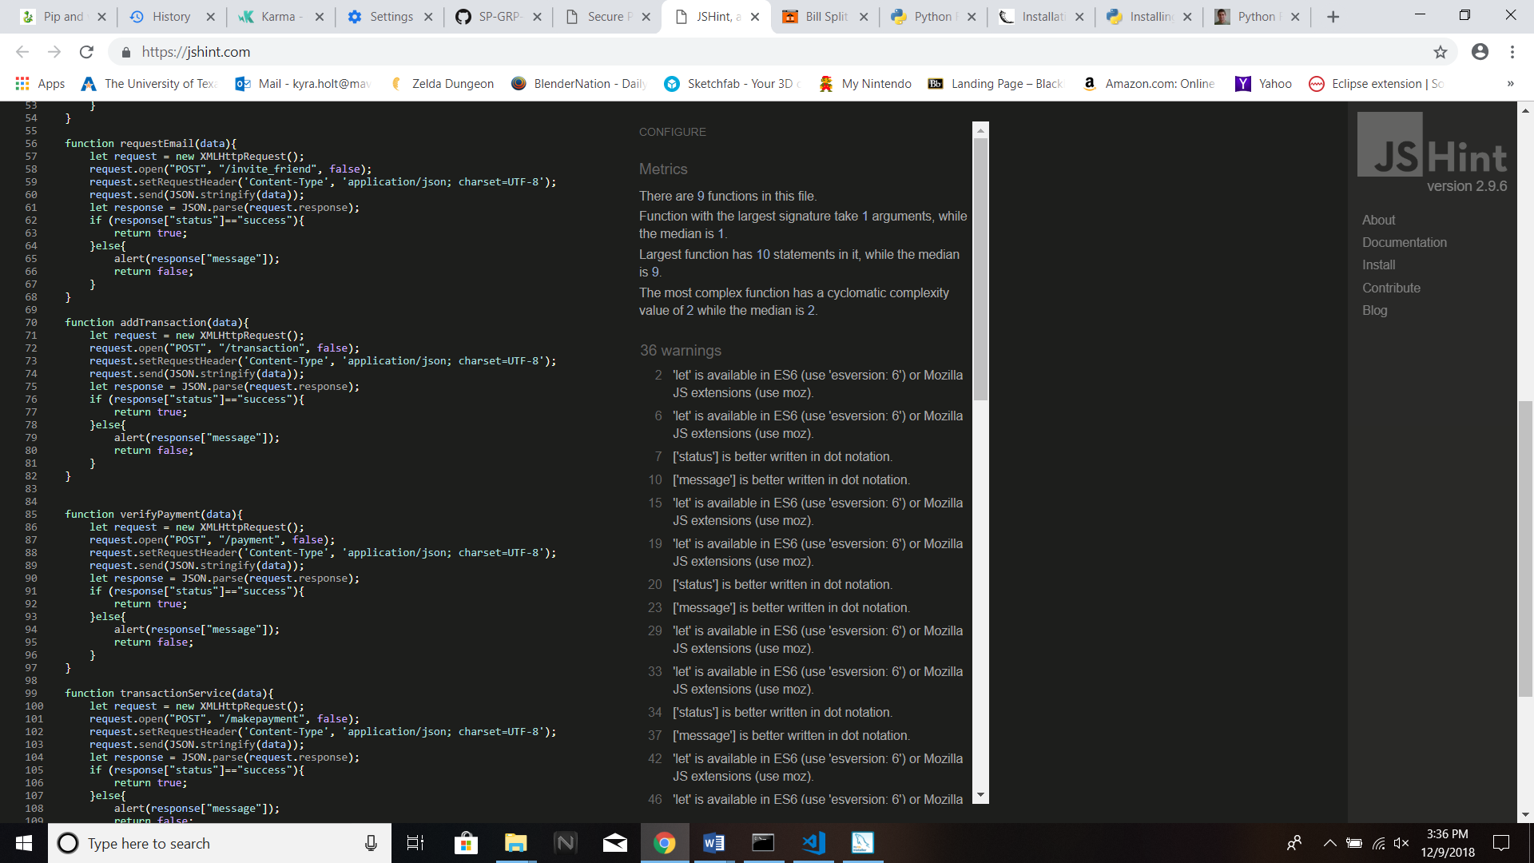

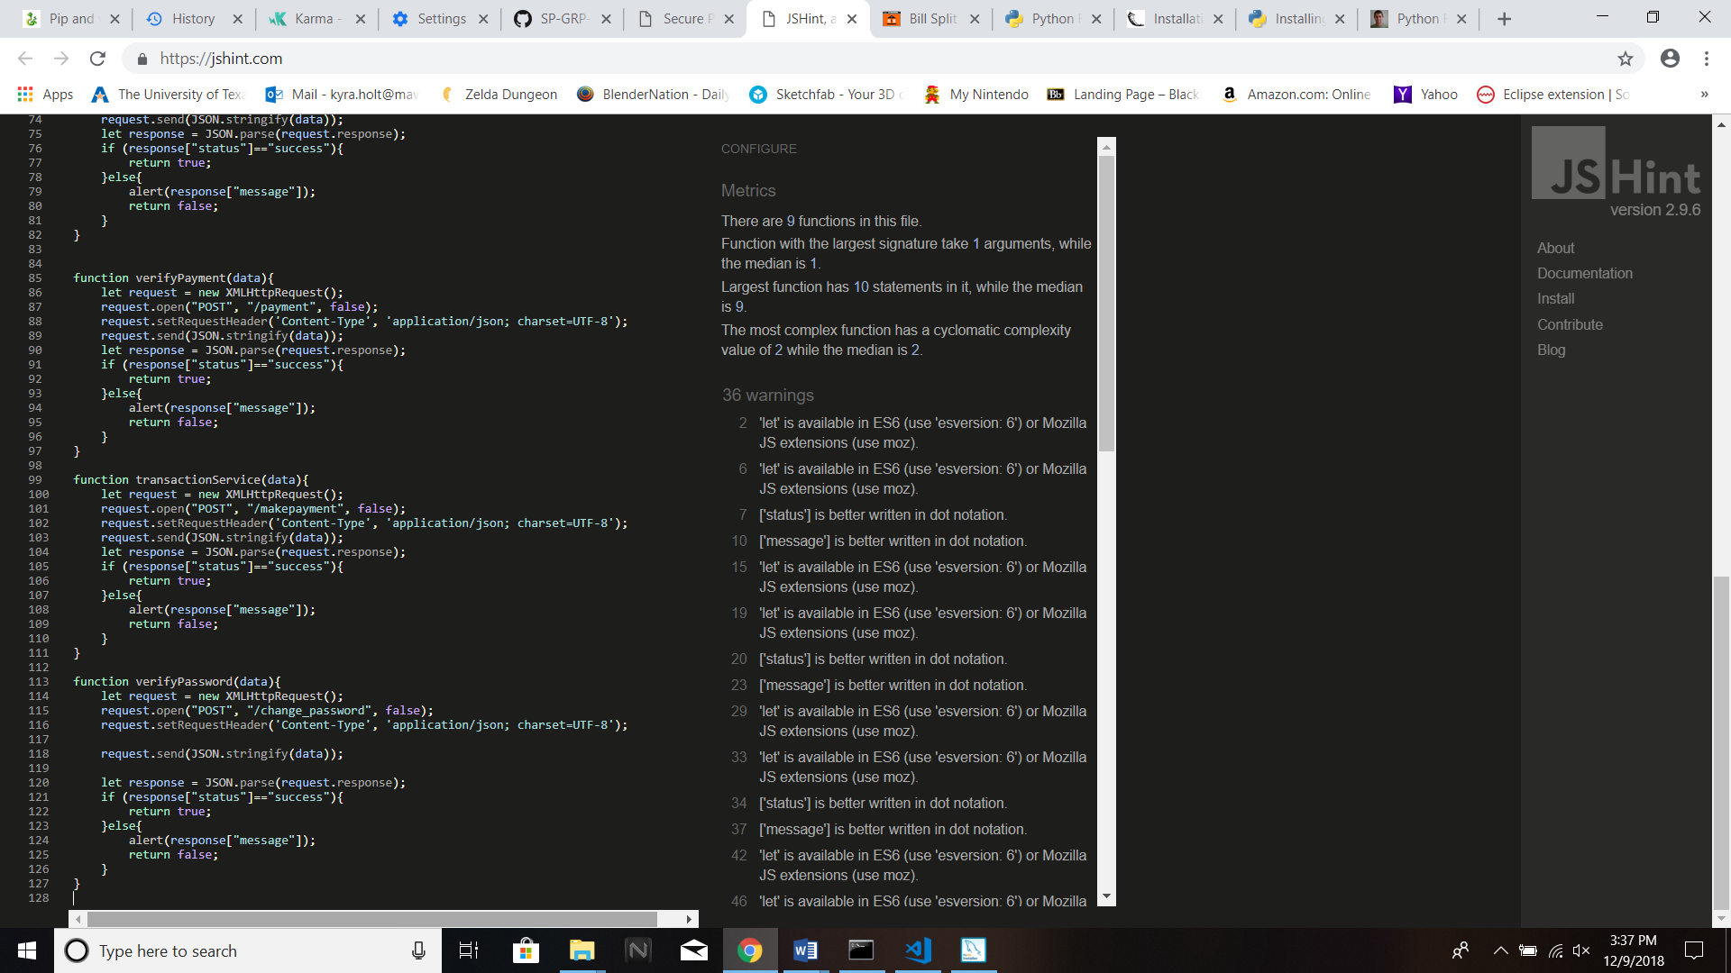

**Results for Validator.js**

***51 warnings***

358 ['firstname'] is better written in dot notation.

365 ['lastname'] is better written in dot notation.

372 ['email'] is better written in dot notation.

379 ['card_number'] is better written in dot notation.

386 ['phone'] is better written in dot notation.

393 ['password'] is better written in dot notation.

402 ['answer'] is better written in dot notation.

407 'let' is available in ES6 (use 'esversion: 6') or Mozilla JS extensions (use moz).

415 ['card_number'] is better written in dot notation.

416 ['card_expiry_month'] is better written in dot notation.

417 ['card_expiry_year'] is better written in dot notation.

418 ['card_name'] is better written in dot notation.

419 Missing semicolon.

428 Missing semicolon.

429 Missing semicolon.

437 ['pay'] is better written in dot notation.

437 ['email'] is better written in dot notation.

444 ['pay'] is better written in dot notation.

444 ['name'] is better written in dot notation.

451 ['pay'] is better written in dot notation.

451 ['phone'] is better written in dot notation.

464 Missing semicolon.

472 ['shair'] is better written in dot notation.

472 ['money'] is better written in dot notation.

479 ['shair'] is better written in dot notation.

479 ['payer_id'] is better written in dot notation.

488 Missing semicolon.

498 ['request'] is better written in dot notation.

498 ['money'] is better written in dot notation.

505 ['request'] is better written in dot notation.

505 ['identifier'] is better written in dot notation.

512 ['request'] is better written in dot notation.

512 ['topay'] is better written in dot notation.

519 ['request'] is better written in dot notation.

519 ['phone'] is better written in dot notation.

533 ['login'] is better written in dot notation.

533 ['email'] is better written in dot notation.

540 ['login'] is better written in dot notation.

540 ['password'] is better written in dot notation.

547 ['login'] is better written in dot notation.

547 ['code'] is better written in dot notation.

552 'let' is available in ES6 (use 'esversion: 6') or Mozilla JS extensions (use moz).

555 Missing semicolon.

563 ['changepass1'] is better written in dot notation.

569 ['changepass1'] is better written in dot notation.

569 ['verify'] is better written in dot notation.

579 'let' is available in ES6 (use 'esversion: 6') or Mozilla JS extensions (use moz).

581 Missing semicolon.

593 ['changepass2'] is better written in dot notation.

593 ['email'] is better written in dot notation.

600 ['changepass2'] is better written in dot notation.

600 ['token'] is better written in dot notation.

606 ['changepass2'] is better written in dot notation.

606 ['password'] is better written in dot notation.

612 ['changepass2'] is better written in dot notation.

612 ['retype'] is better written in dot notation.

637 Missing semicolon.

645 'let' is available in ES6 (use 'esversion: 6') or Mozilla JS extensions (use moz).

648 Missing semicolon.

655 ['invite_email'] is better written in dot notation.

655 ['email'] is better written in dot notation.

662 Missing semicolon.

***Ten undefined variables***

336 re

337 re

420 registerUser

428 logoutService

460 data

485 data

489 data

635 data

638 data

660 data

663 data

489 addTransaction

556 loginService

582 verifyPassword

638 verifyEmail

649 transactionService

663 requestEmail

***16 unused variables***

579 data

218 isValidCVV

234 isValidUserID

252 isValidAnswer

270 isValidDate

335 isValidToken

356 validateSignUp

426 validateLogout

435 validateMakePayment

470 validateShareBill

496 validateRequest

531 validateLogIn

562 validatePasswordChangeLoggedIn

591 validatePasswordChangeNotLoggedIn

629 validateSendEmail

644 updateTransaction

654 validateInviteFriend

**Fixed Code:**

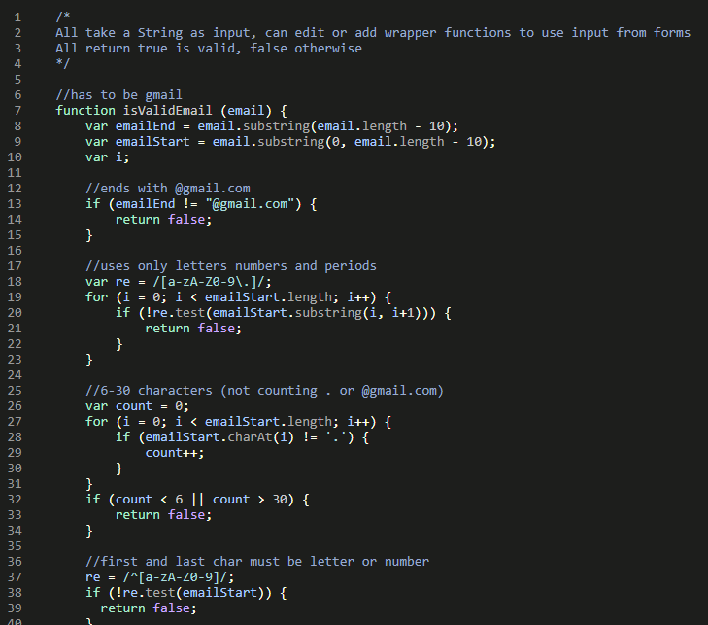

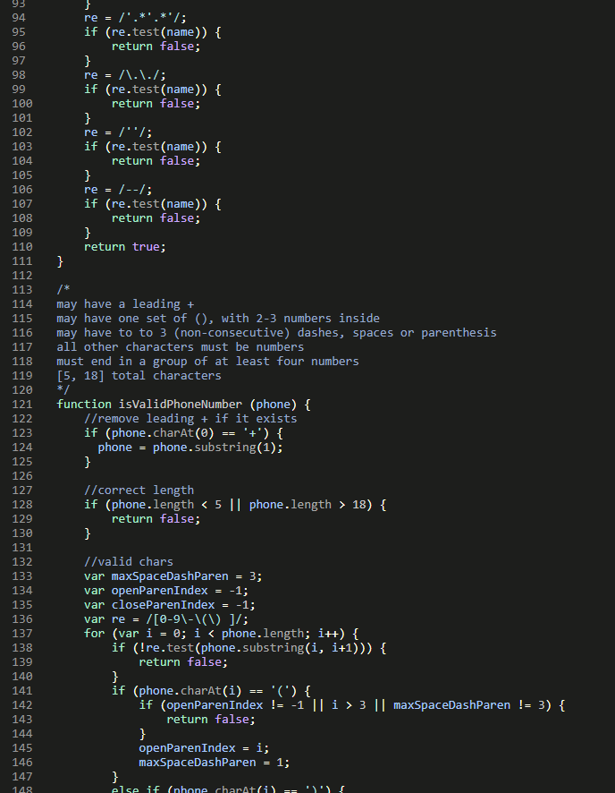

\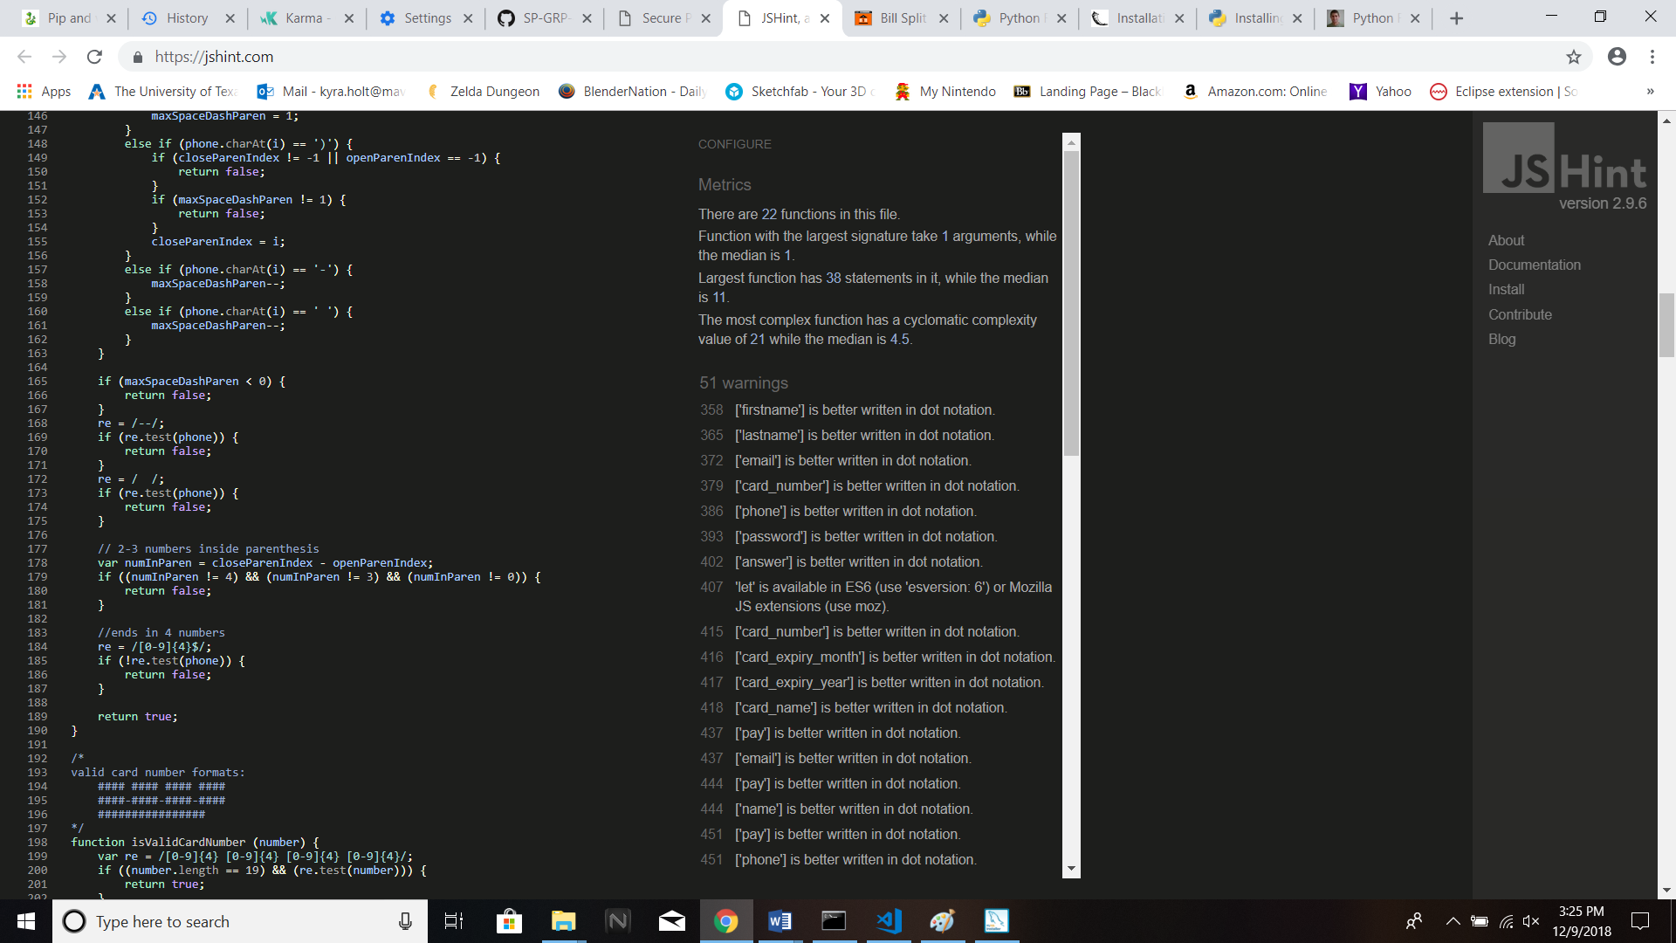

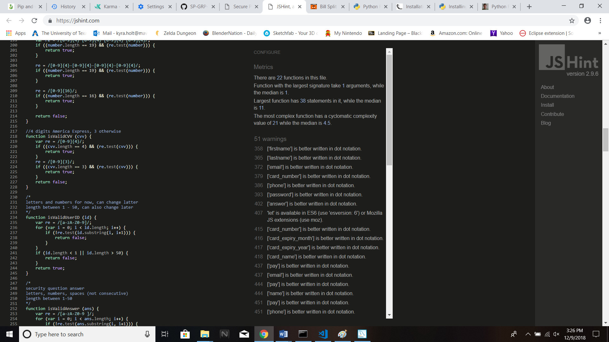

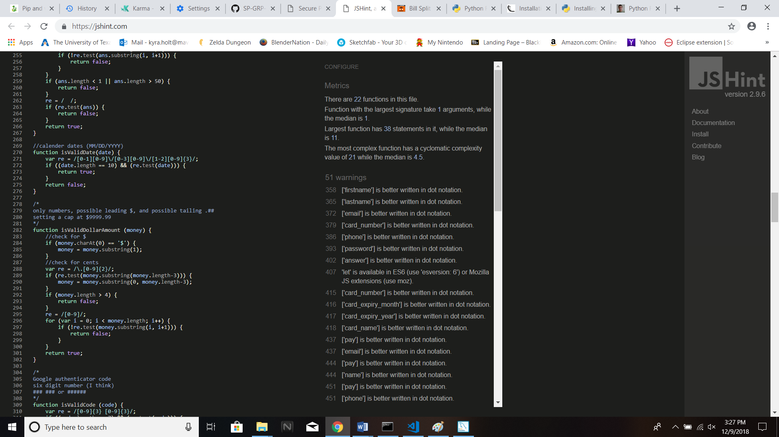

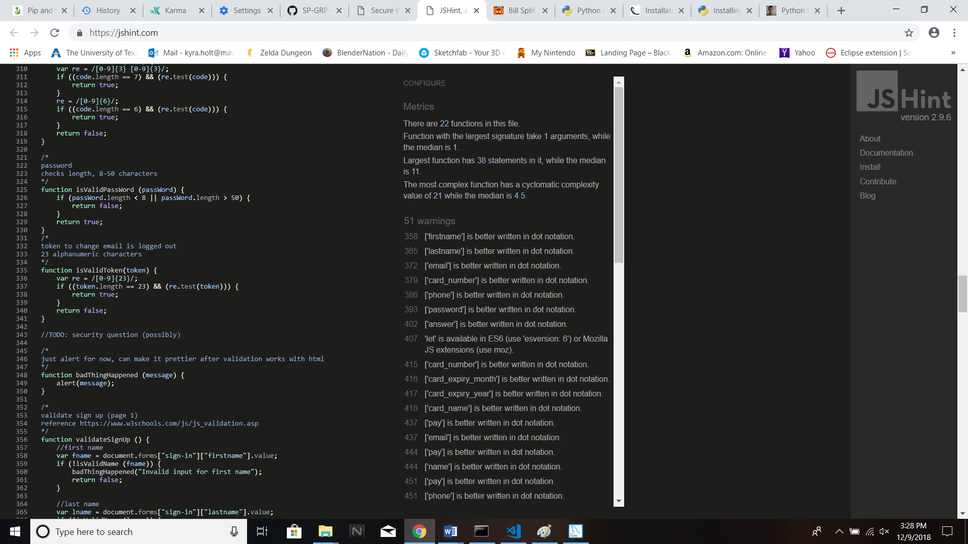

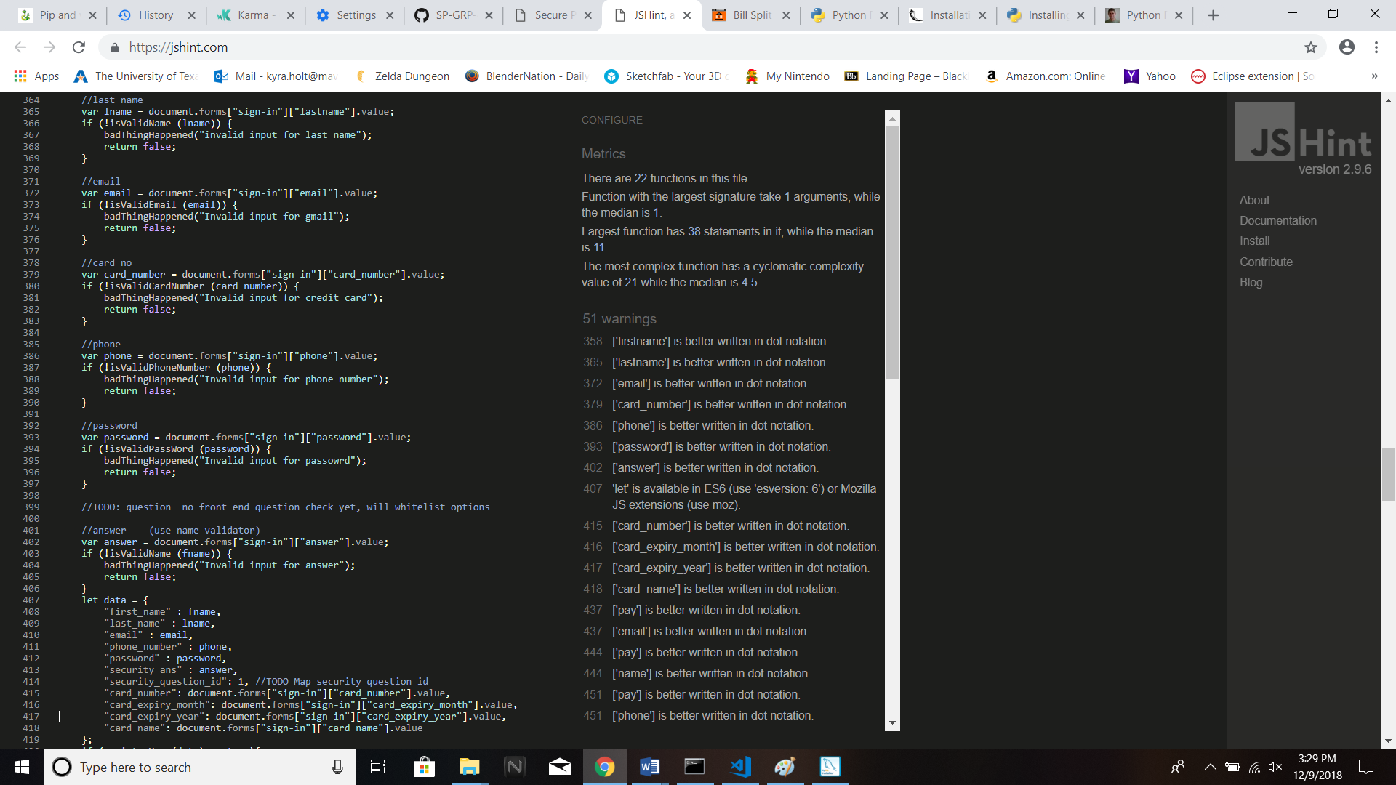

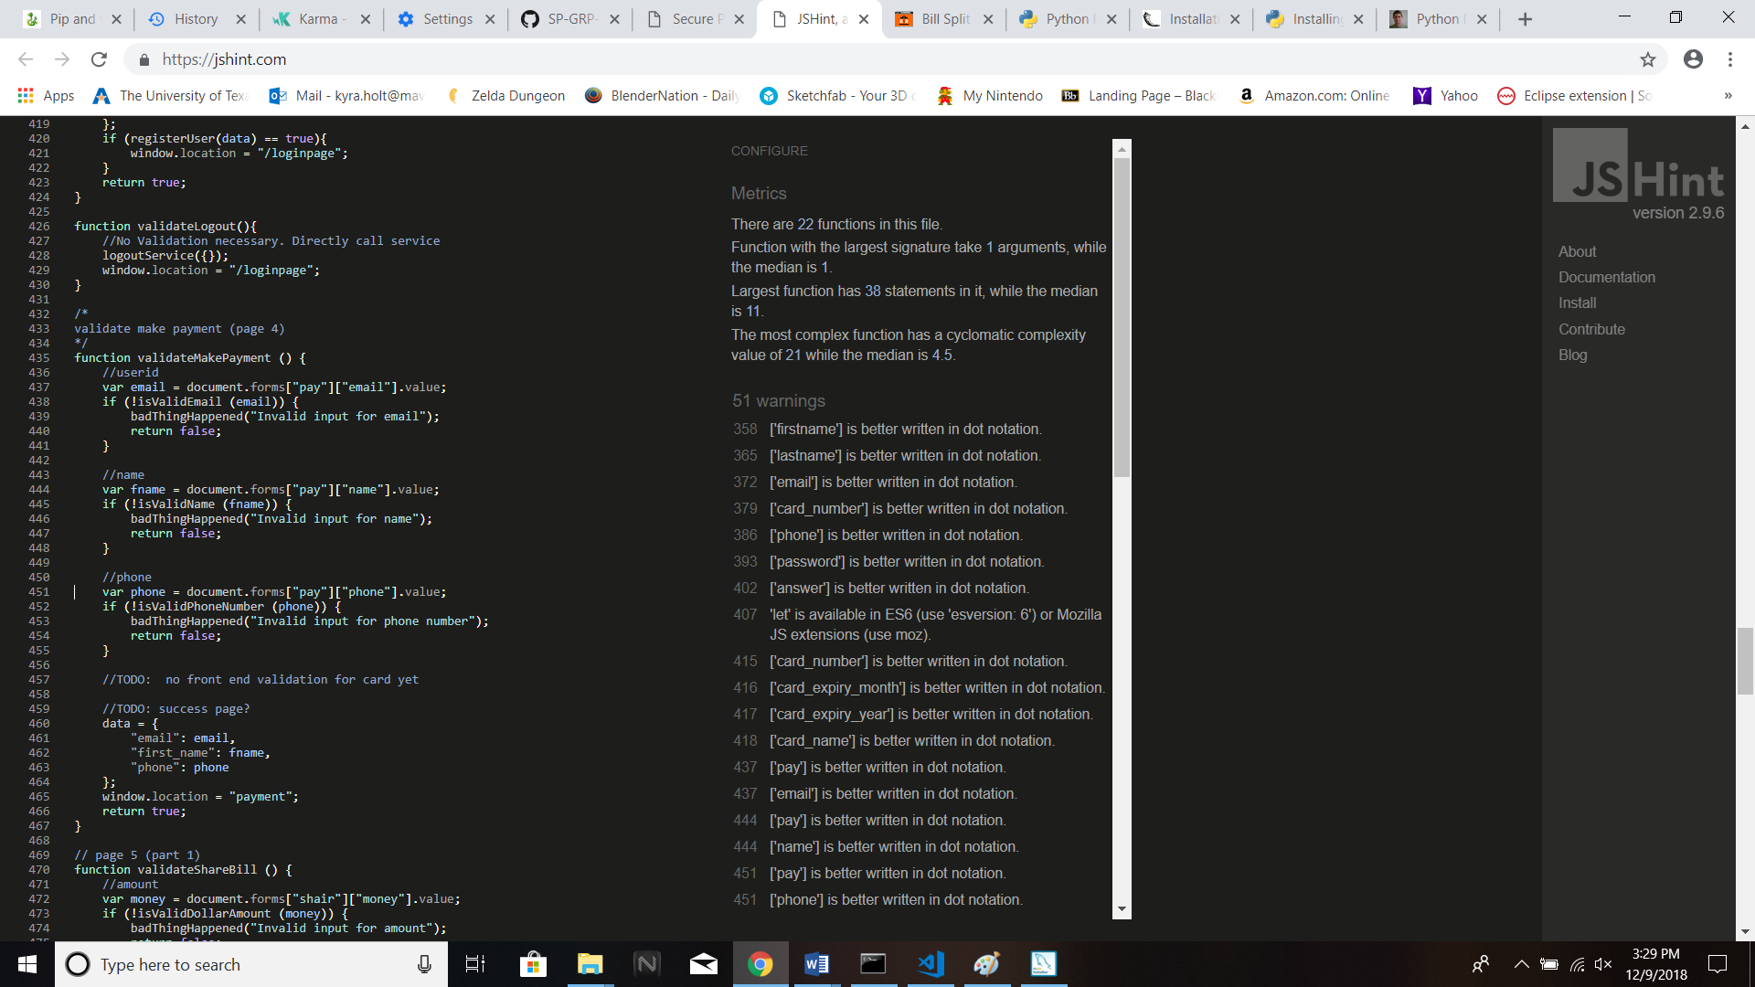

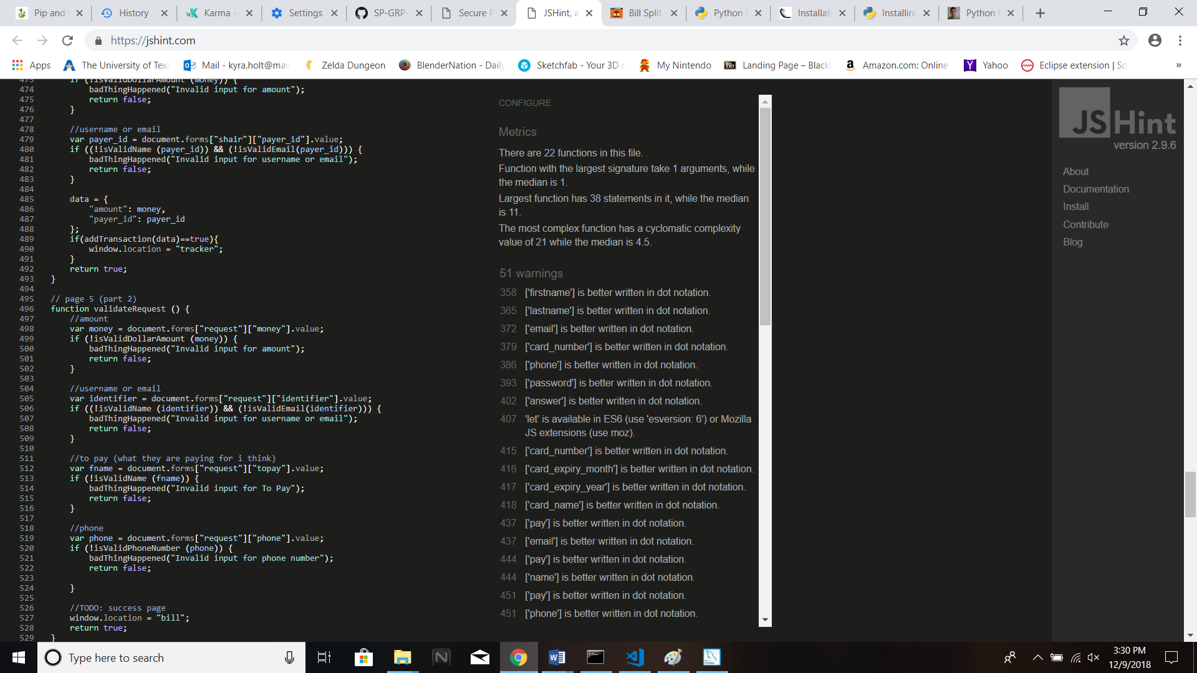

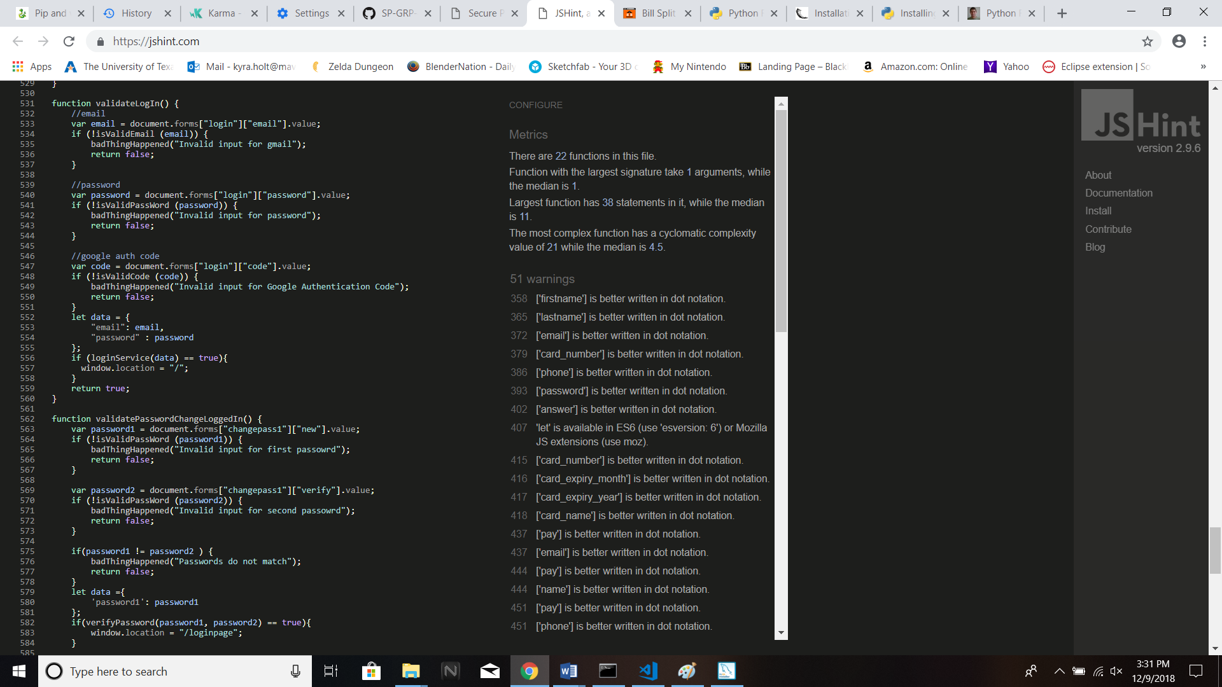

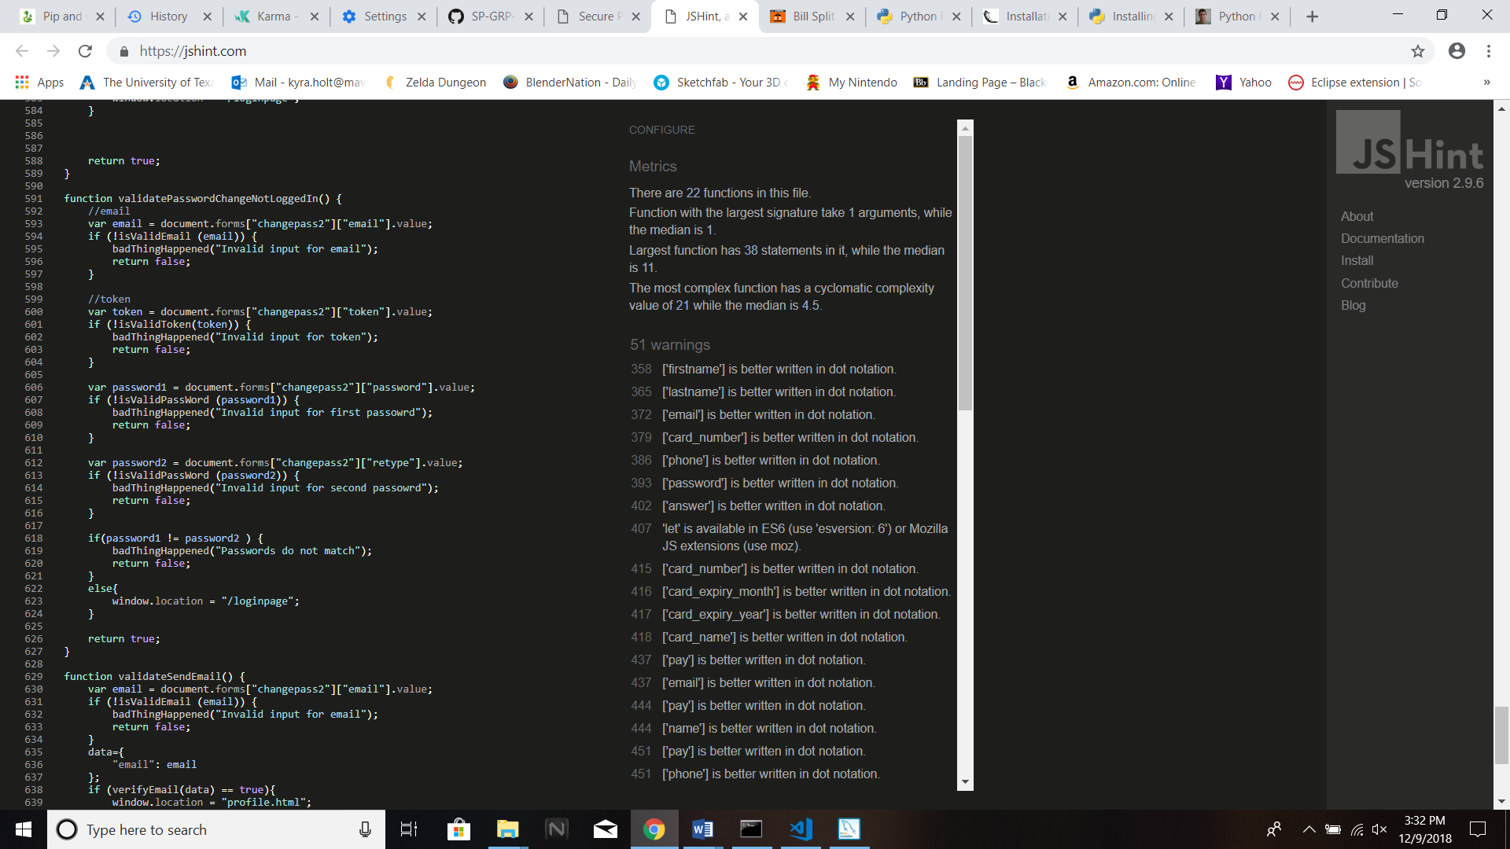

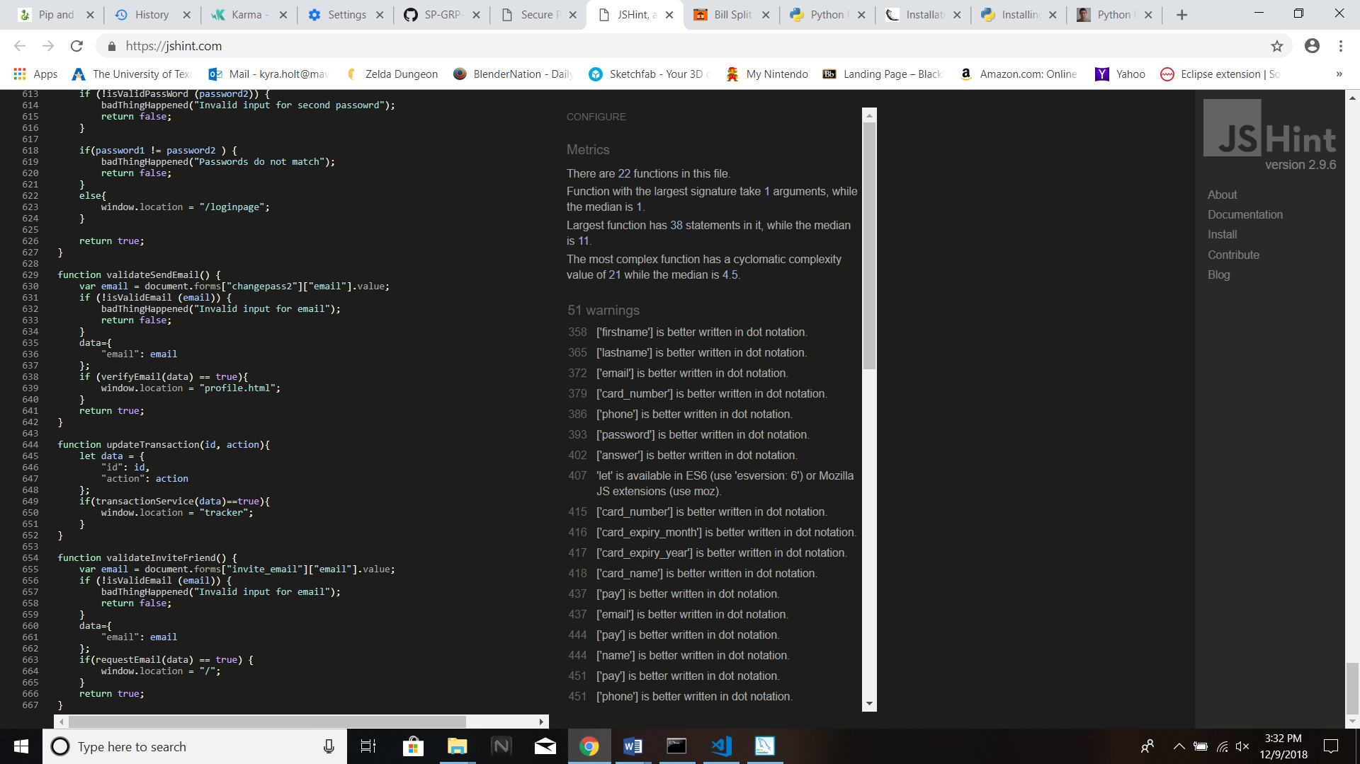

**HTML Tidy**

HTML Tidy is a tool which is used for correcting invalid HTML source codes and it does so by pointing out web accessibility errors, and points towards issues in the layout and indent style of the resulting markup.

For this Static Analysis, we will be running HTML Tidy via an Online tool at (<https://infohound.net/tidy/>) on all the static webpages source codes located inside the /…/templates folder.

**Rules Used:**

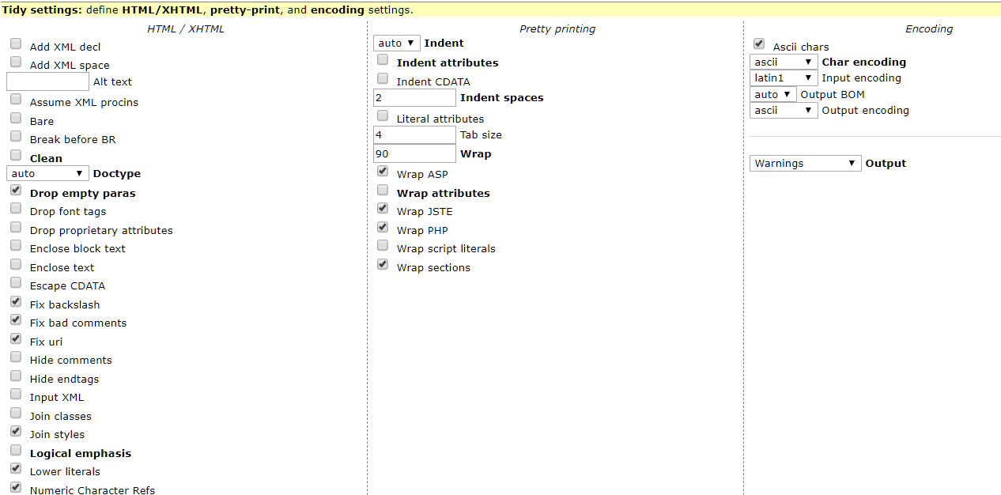

1. **Page name: index.html (Homepage)**

**Running HTML Tidy on the source code of this page generates the following errors:**

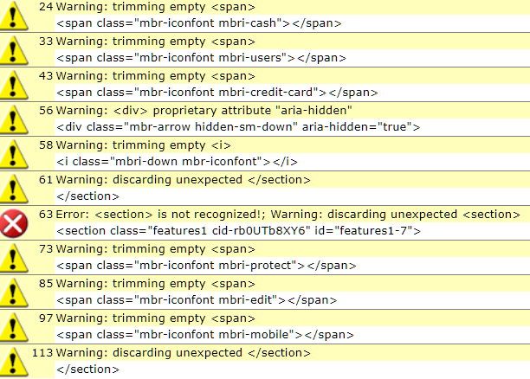

**Fixing all the errors and warnings, we get the following source code excerpts:**

*For Lines 24 to 43:*

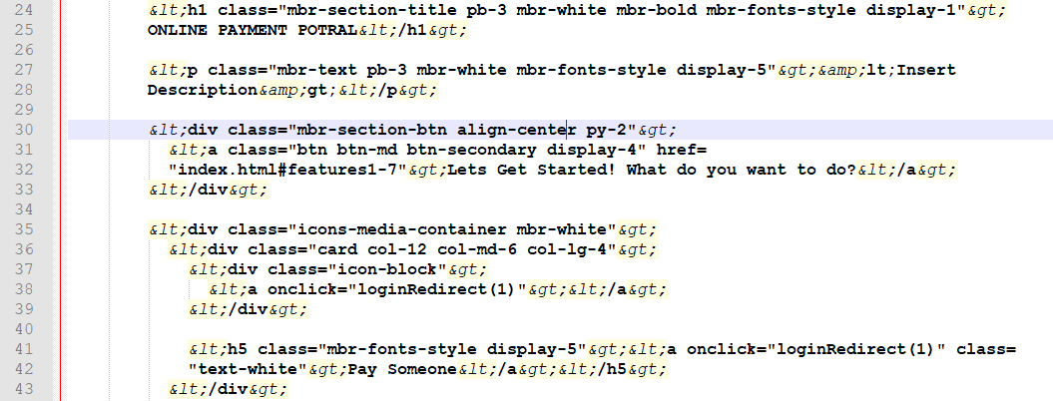

*For Lines 56 to 85:*

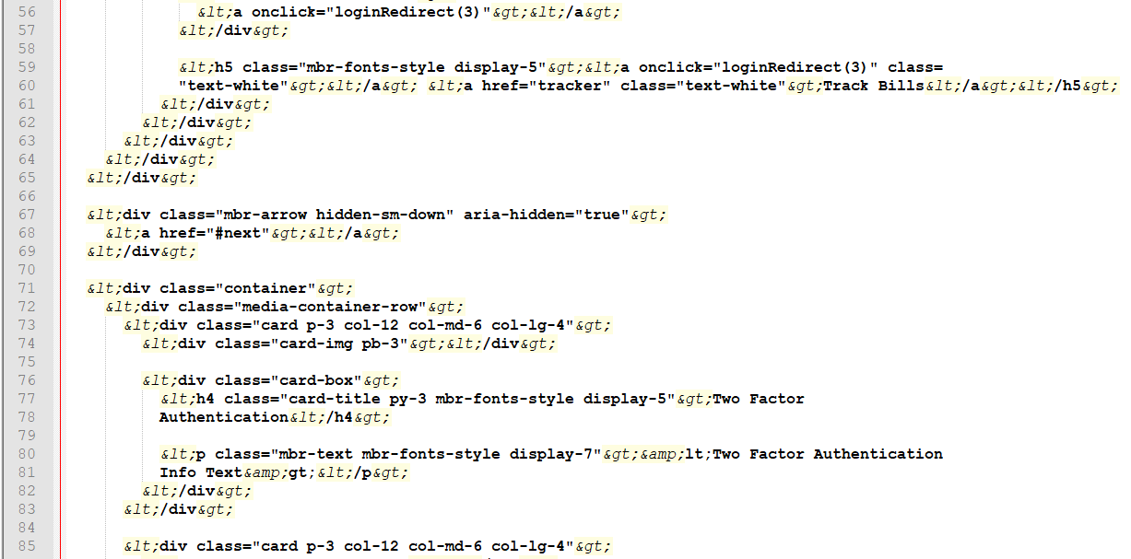

*For the error in Line 97 and line 113 was removed since it was redundant.*

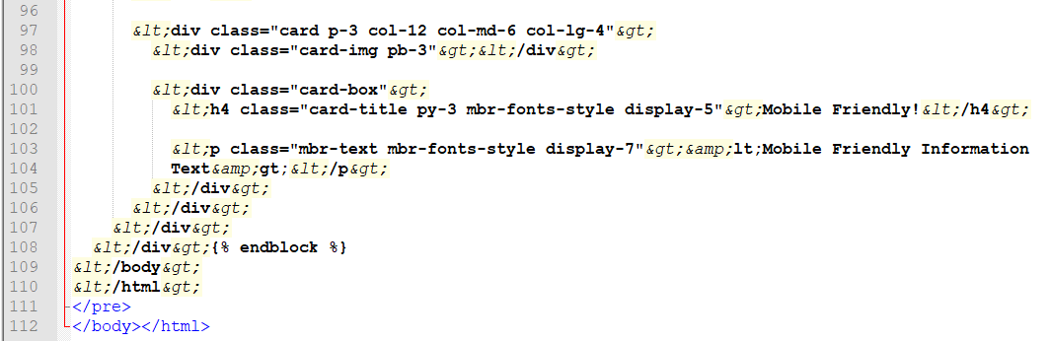

1. **Page name: login.html (Signup & Login)**

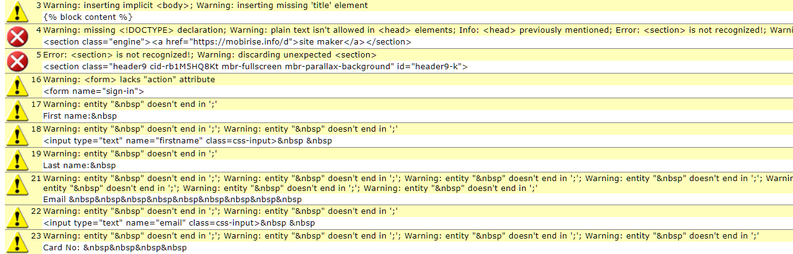

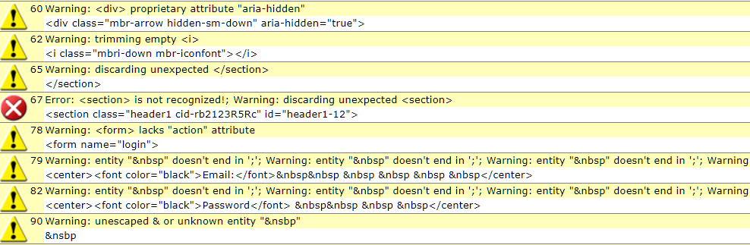

**Fixing all the errors and warnings, we get the following source code excerpts:**

*For Lines 3 to 23:*

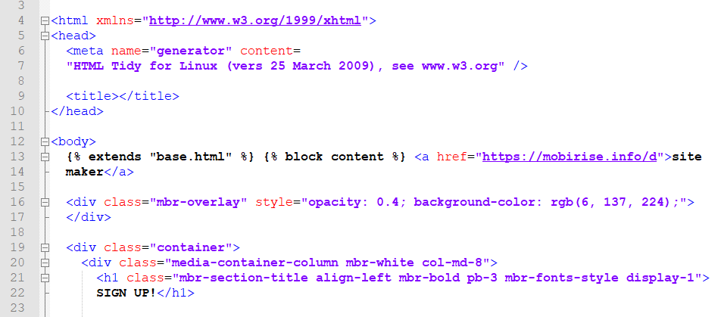

*For Lines 60 to 90:*

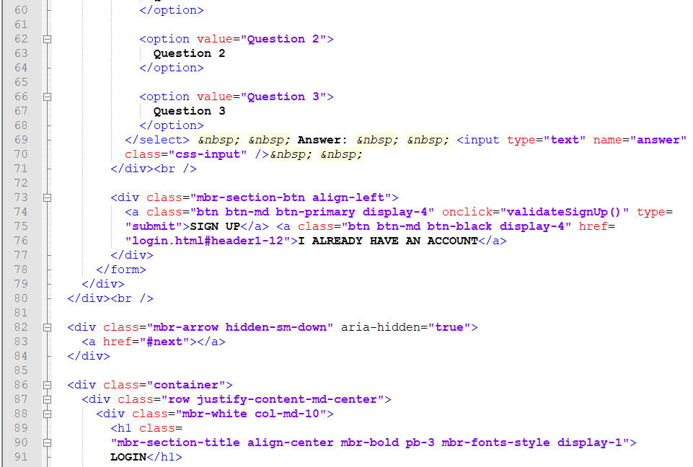

1. **Page name: bill.html (Bill Split)**

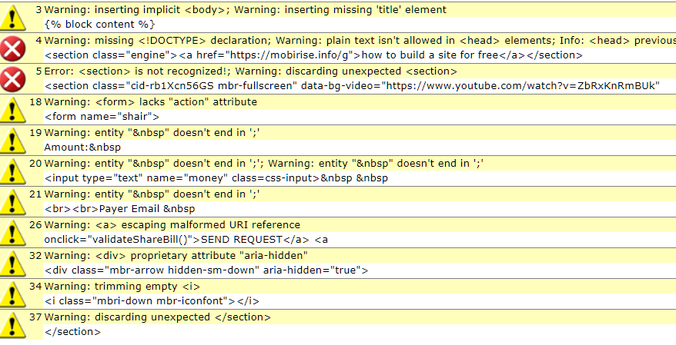

**Fixing all the errors and warnings, we get the following source code excerpts:**

*For lines 3 to 37:*

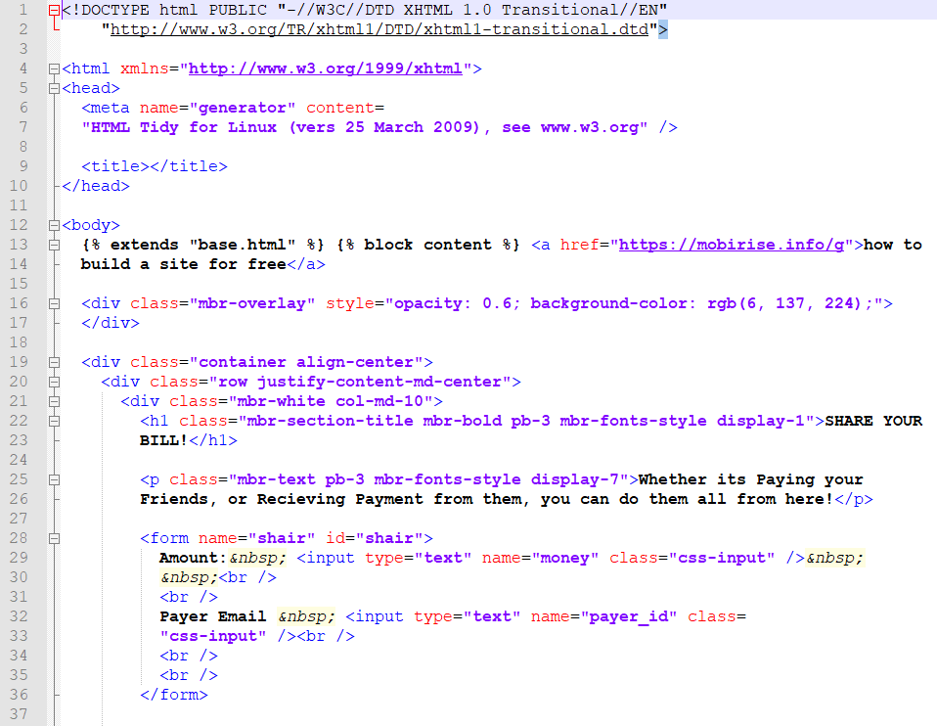

1. **Page name: changepassword.html (Change Password)**

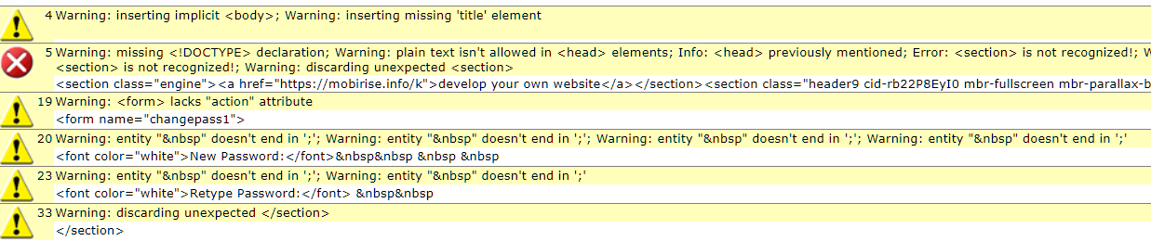

**Fixing all the errors and warnings, we get the following source code excerpts:**

*For Lines 4 to 33:*

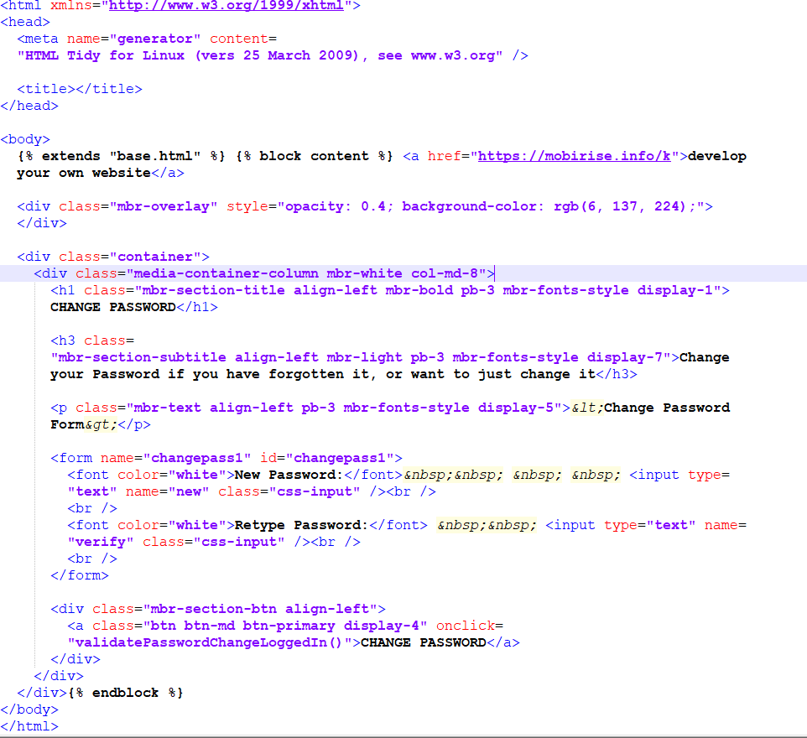

**5. Page name: forgotpassword.html (Forgot Password)**

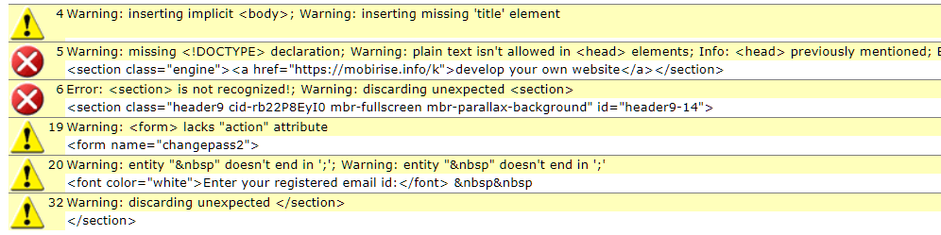

**Fixing all the errors and warnings, we get the following source code excerpts:**

*For Lines 4 to 32*

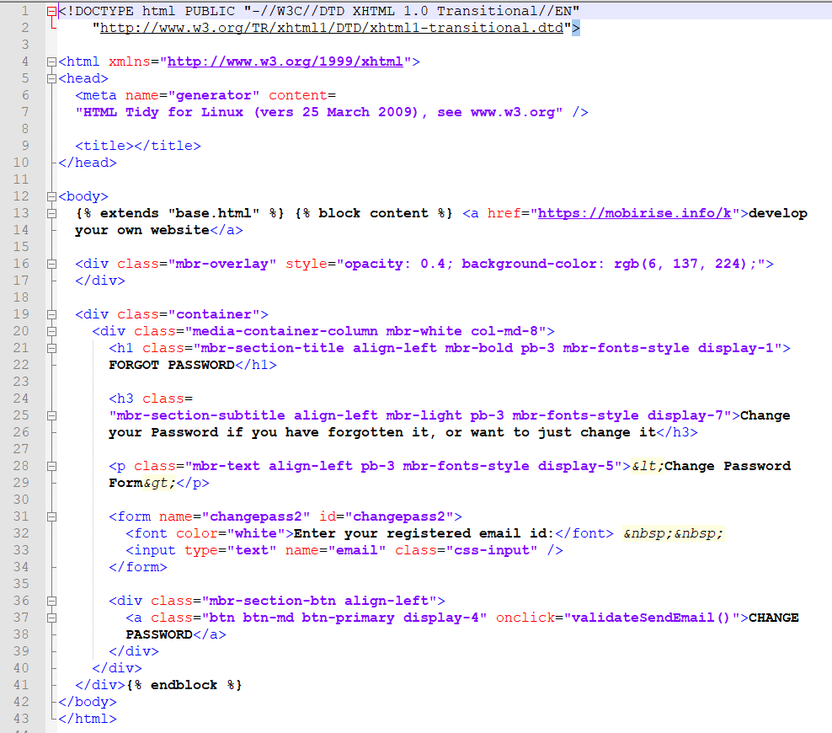

1. **Page name: invitesuccess.html**

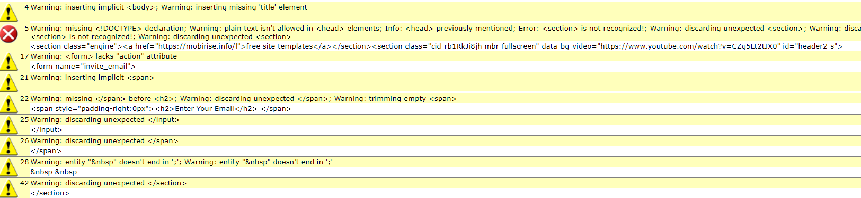

**Fixing all the errors and warnings, we get the following source code excerpts:**

*For Lines 4 to 42:*

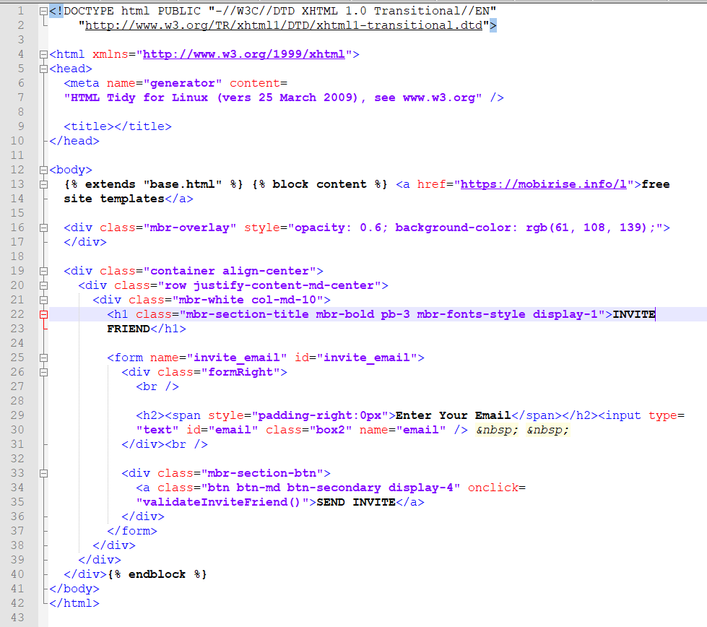

1. **Page name: payment.html(Payment)**

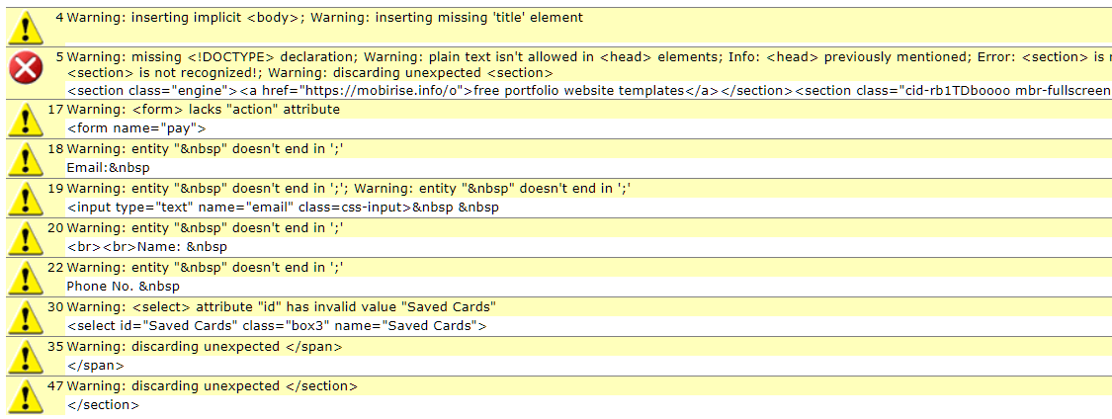

**Fixing all the errors and warnings, we get the following source code excerpts:**

*For Lines 4 to 47:*

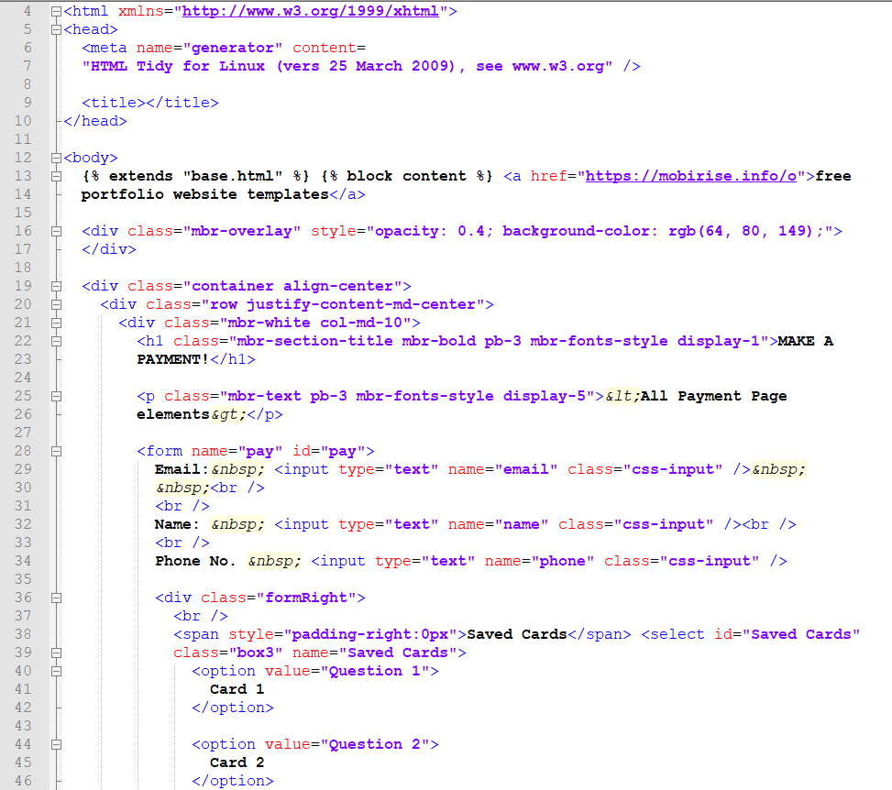

1. **Page name: pending.html**

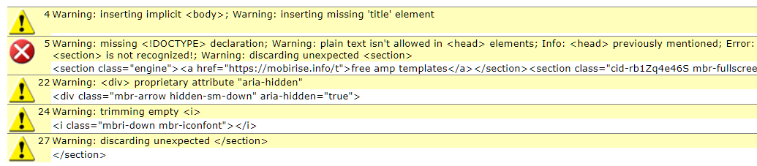

**Fixing all the errors and warnings, we get the following source code excerpts:**

*For Lines 4 to 27:*

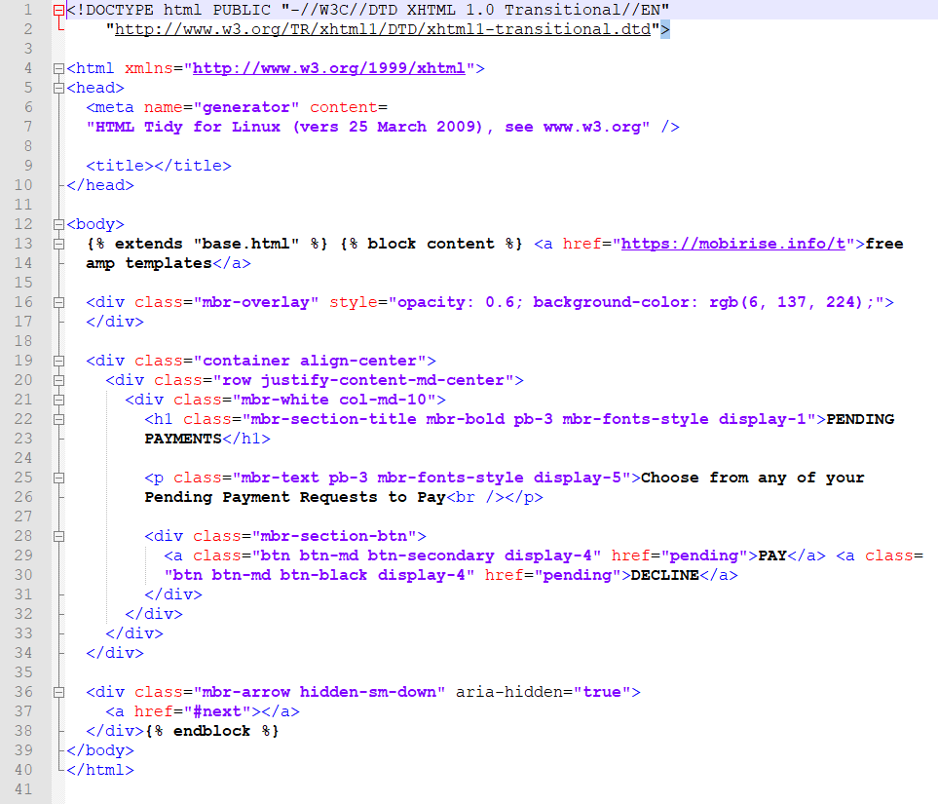

1. **Page name: profile.html**

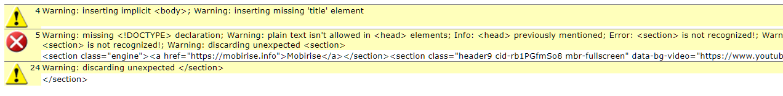

**Fixing all the errors and warnings, we get the following source code excerpts:**

*For Lines 4, 5 and 24:*

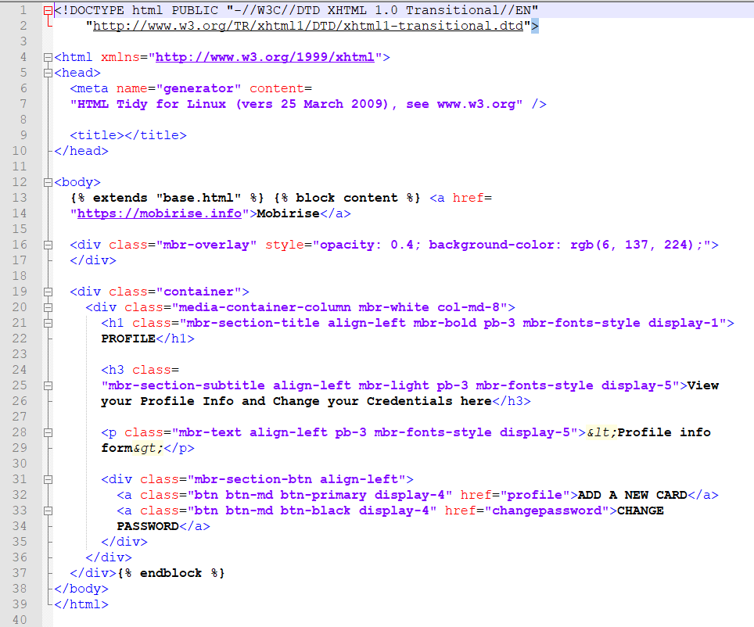

**10) Page name: tracker.html**

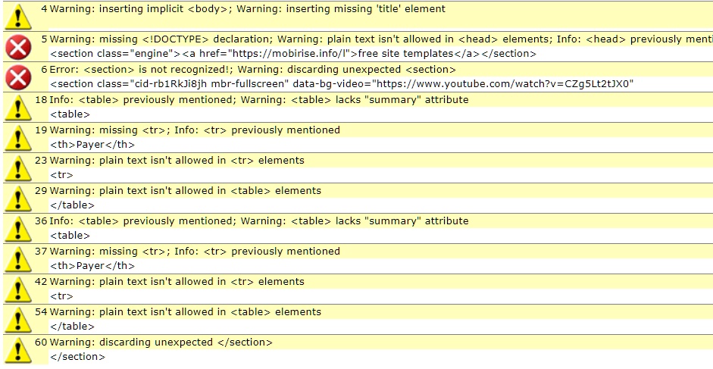

**Fixing all the errors and warnings, we get the following source code excerpts:**

*For Lines 4 to 60:*

